Dogleg Clearance Measurements

Version 4

Janet Fraser, Craig Macwaters, John Matheson and Tony Weidberg 26/8/02

Introduction.
One of the most critical areas for the clearances in the SCT is between the top of the cover over the opto-package to the module hybrid. The new barrel 3 design has an 11⁰ tilt for the modules and an active radius of the silicon of 299.5 mm (see the engineering drawing on CDD). The design changes have been made in such a way as to be compatible with existing doglegs, but this needs to be confirmed by measurements on prototype structures. We also need to verify that the compliance in the doglegs is sufficient to allow for:
- The variation in the radius of the actual barrel surface. The worst case variation is expected to be 1.25 mm.
- The variation along the harness that occurs because dogleg 1 lies on top of 5 LMT pairs, dogleg 2 lies on top of 4 LMT pairs etc. Therefore the extreme variation in the height of the dogleg from this effect is +1.5 mm.

Measurements Made
We have used the jigs designed by Eric Perrin and Gerrard Barbier, one of which is shown in Figure 1 below.
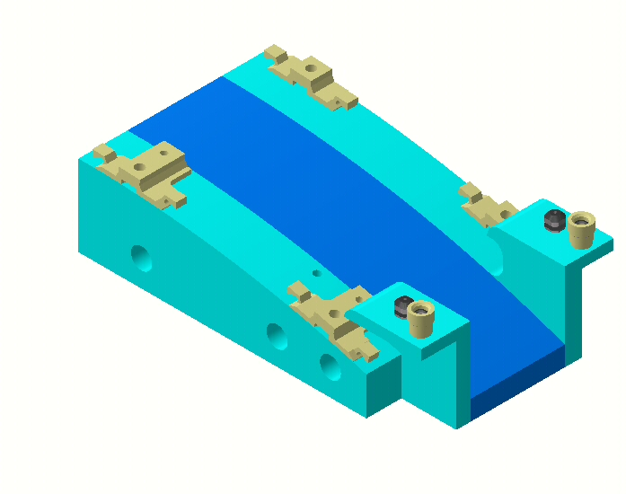
Figure 1 Dogleg mounting jig.
The dogleg is first bent on one of Andy Coyle’s bending jigs and is then mounted on the jig. The part of the dogleg which lies on the surface of the cylinder section is fastened down with a harness clip and the dogleg arms are attached to the jig with the type of nuts that will be used to attach the dogleg to the bracket.

The height of the dogleg surface was measured at the 6 points shown in the dogleg drawing in Figure 2 below. The critical dimensions for the clearances are points 4 and 5 which are on the land where the opto-package and cover will be

Six such mounting jigs have been made, 3 to represent lower modules and 3 for upper modules. For the upper and lower jigs, 3 variations were made to allow for the nominal barrel radius and 1 mm variation. Since only relative measurements are meaningful, the results will be given relative to point 1.
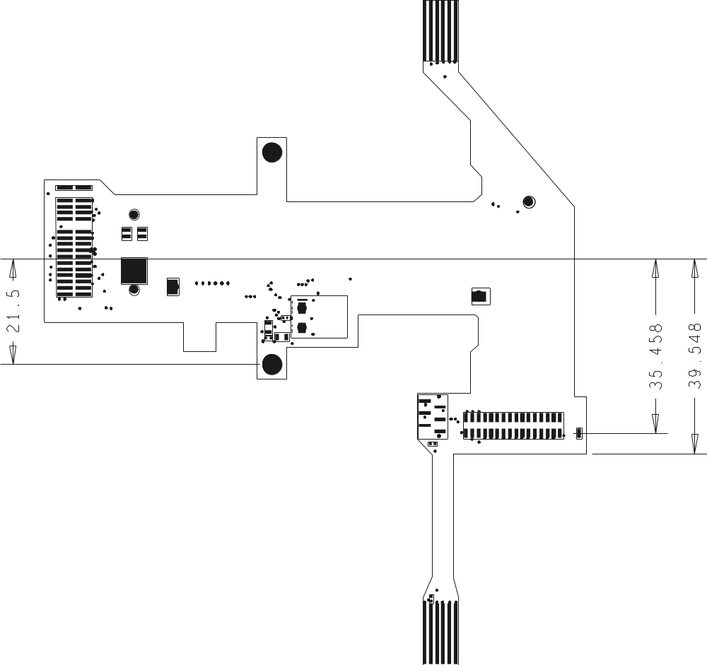
Figure 2 Left hand dogleg with positions used for height measurements.

Results and Discussion
The height measurements are given in Tables 1 to 7 below.

Table 1 Height measurements for short dogleg on lower module at nominal barrel radius-1 mm (R=283 mm) and no LMTs under dogleg.
Position number | Height (mm)
1 | 0 (definition)
2 | 0.06
3 | 0.05
4 | 0.05
6 | 0.03

Table 2 Height measurements for short dogleg on lower module at nominal barrel radius (R=284) mm and no LMTs under dogleg.
Position number | Height (mm)
1 | 0
2 | 0.06
3 | 0.01
4 | 0.01
5 | 0.01
6 | 0.04

Table 3 Height measurements for short dogleg on lower module at nominal barrel radius+ 1mm (R=285) mm 5 LMT pairs under the dogleg.
Position number | Height
1 | 0
2 | 0.42
3 | 0.75
4 | 0.53
5 | 0.17
6 | 0.22

Table 4 Height measurements for long dogleg on upper module at nominal barrel radius-1 mm (R=283 mm) and no LMTs under dogleg.
Position number | Height (mm)
1 | 0 (definition)
2 | -0.03
3 | -0.03
4 | -0.17
5 | -0.20
6 | 0.22

Table 5 Height measurements for long dogleg on upper module at nominal barrel radius+ 1mm (R=285) mm 5 LMT pairs under the dogleg.
Position number | Height
1 | 0
2 | 0.44
3 | 0.66
4 | 0.38
5 | 0.24
6 | 0.19

Table 6 Height measurements for long dogleg on upper module at nominal barrel radius+ 1mm (R=285) mm 5 LMT pairs under the dogleg. For these measurements the dogleg was clamped firmly to the bracket with the addition of washers. The worst case position of the dogleg in the mounting hole was used.
Position number | Height (mm)
1 | 0.0
2 | 0.085
3 | 0.27
4 | -0.14
5 | -0.17
6 | 0.145

Table 7 Height measurements for a SHORT dogleg on an UPPER module at nominal barrel radius- 1mm (R=283) mm with no LMT pairs under the dogleg. For these measurements the dogleg was clamped firmly to the bracket with the addition of washers. The worst case position of the dogleg in the mounting hole was used.

Position number | Height (mm)
1 | 0.0
2 | 0.02
3 | -0.18
4 | -0.175
5 | -0.19
6 | 0.26

Clearances to Envelope Module
A dummy “envelope module” was mounted on the jig for an upper module, with barrel radius 283 mm (nominal-1 mm). A short dogleg was used to take a worst case and the dogleg was firmly attached to the bracket by adding washers. The distance from the dogleg surface to the surface of the “hybrid” was measured with a microscope. The result was 3.018 mm which compares well with the expected value of 2.99 mm (1.6 mm for the height of the opto-package plus 1.39 mm clearance).
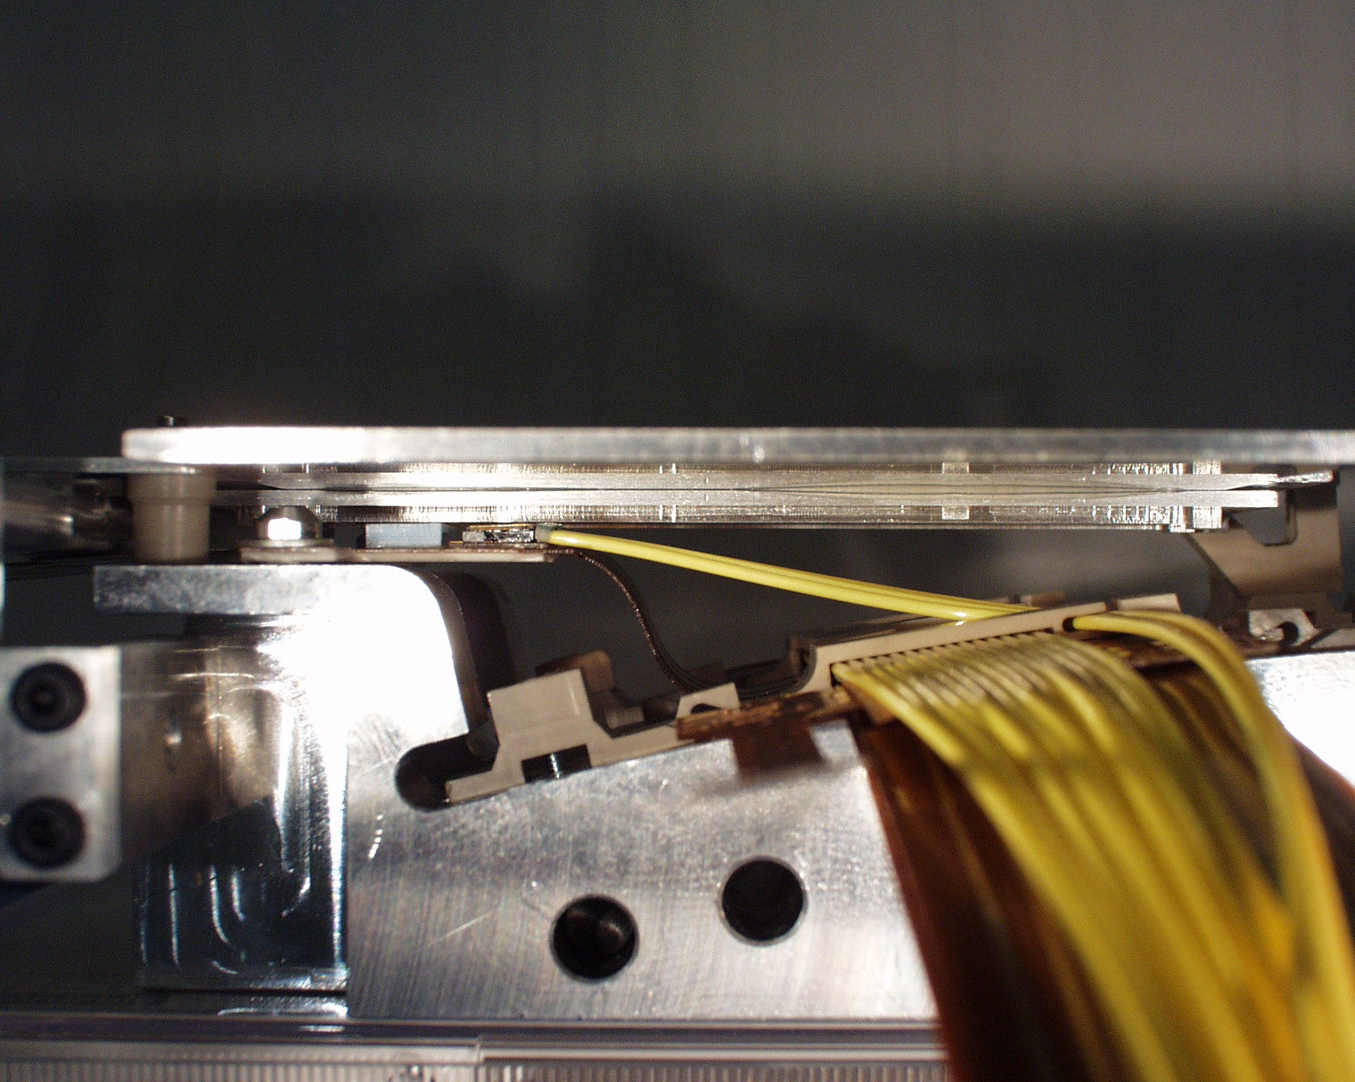
Figure 3 Side view of long dogleg and envelope module on mounting jig.

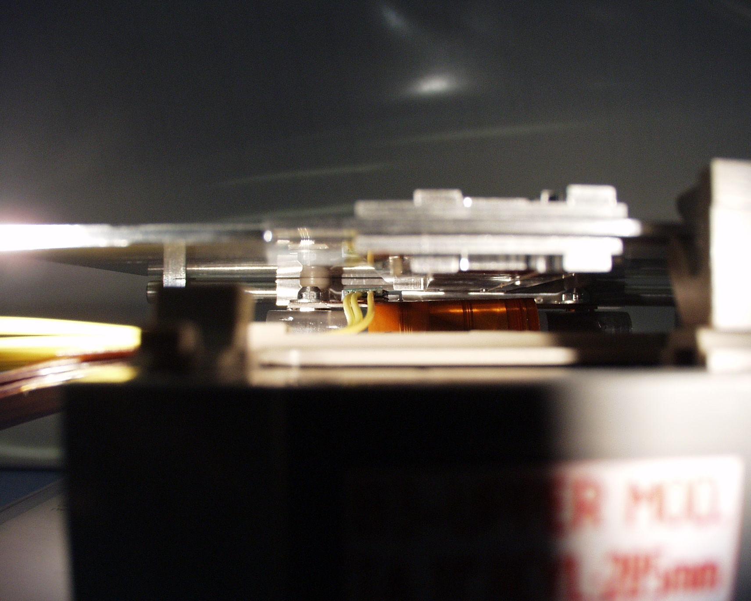
Figure 4 End view of long dogleg and envelope module on mounting jig.
Further tests of the clearances to the envelope module were made by adding opto-packages and opto-covers to the doglegs. The lids used were of on old design and had heights of 1.63 0.05 mm, whereas the new design will respect the 1.6 mm tolerance. Since the clearance is most critical at the RHS edge of the cover, the cover was positioned so that the RHS edge lay where the RHS edge of a new style cover would lie. In order to simulate the worst case, the jig representing barrel radius+1mm and the full LMT tape stack were used. The clearances for a long dogleg are shown in below.

The clearances are good provided the dogleg is clamped to the bracket. The clearances were estimated using slip gauges to be in the range 1.39-1.43 mm, which aggress well with the nominal clearance of 1.39 mm. From the end view it can be seen that the clearance is tightest at the RHS edge of the opto-package and chip cover. If the dogleg is not well centred in its tape clamp, the RHS edge can tilt up. The behaviour of the short dogleg was practically identical to that of the long dogleg.
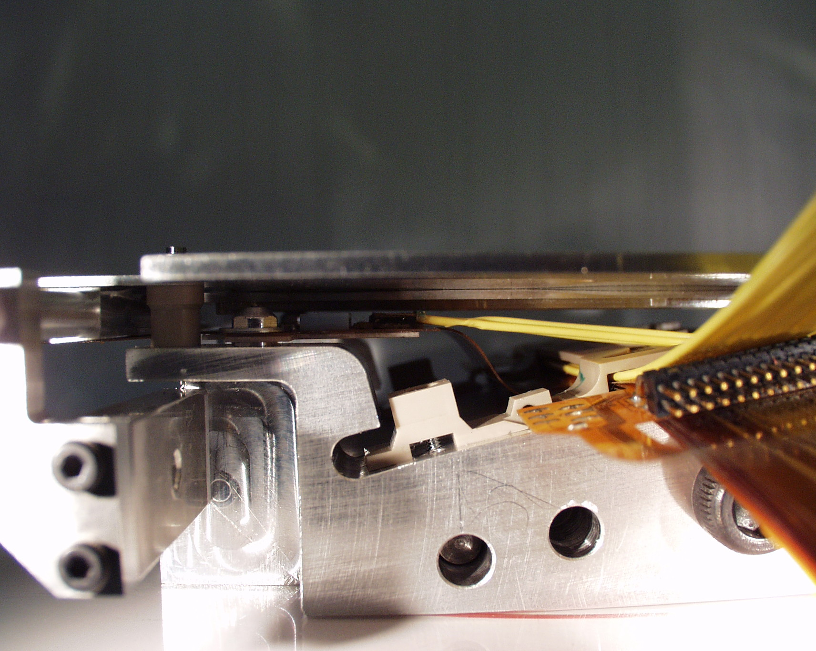
Figure 5 Short dogleg and envelope module on mounting jig.

Summary and Discussion
The results show that the lower dogleg fits very well with the nominal radius if there are no LMTs under the dogleg. Therefore the changes to the tilt angle and barrel radius do not require any change to the dogleg design. There appears to be sufficient compliance in the dogleg to accommodate the -1mm shift in barrel radius as seen for the lower and upper modules. The one case where we have seen significant problems are when we have a barrel radius+1mm and 5 LMT pairs under the dogleg. In these cases the doglegs do not lie flat on the bracket surface and we can lose up to 0.5 mm in the vertical clearance (out of 1.39 mm in the new design). A very significant improvement is observed when the dogleg is clamped firmly to the bracket by adding washers (see Table 6). In this case the AlN is forced to lie flat on the bracket which prevents the dogleg bending up in the dangerous region under the opto-package. Given the good results for the cases where we have barrel radius-1mm we should be able to optimise the dogleg bending jig to further optimise the bending jig. As a first quick check of this idea we have tried mounting a short dogleg on an upper module with a barrel radius 1mm less than the nominal radius. The results shown in Table 7 demonstrate that this works quite well. In this case the dogleg bends gently down so the clearances are actually slightly increased rather than decreased.

The current bending jig appears to be correct for the nominal barrel radius if there are no LMTs under the dogleg. With the current bending jig, the dogleg can accommodate the variations in height if the dogleg is firmly clamped to the bracket. More work is still required to prove that an optimised bending jig will improve the situation and to understand if one jig can be used for all upper (lower) modules or if different jigs are required for the different barrel positions to allow for the thickness of the LMT pairs under the dogleg. More tests of these clearances should also be performed on the first pre-series harness.

CDD drawing ATLSBB30020.

